1. INTRODUCTION
   1. Overview

Consider the type of blogs you can post on social

Media to increase web traffic and brand awareness.

* 1. Purpose

The main purpose of social media postsis to increase

Brand awareness and visibility.

1. Problem Definition & Design Thinking
   1. Empathy map

Paste the empathy map screenshot

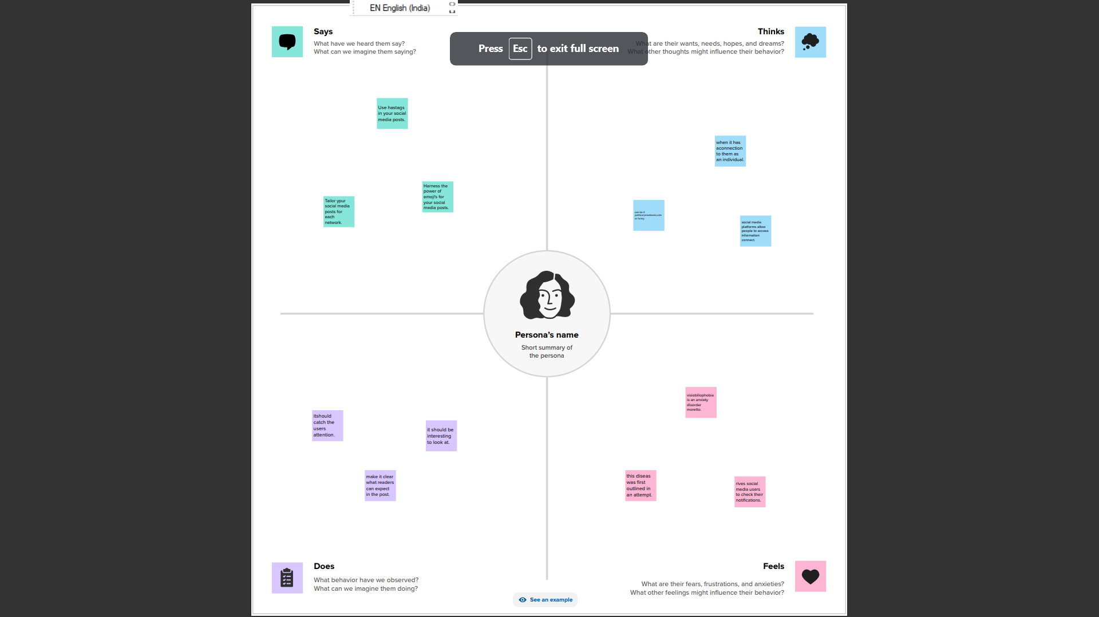

* 1. Ideation & brainstorming map

Paste the ideation & brainstorming map screenshot

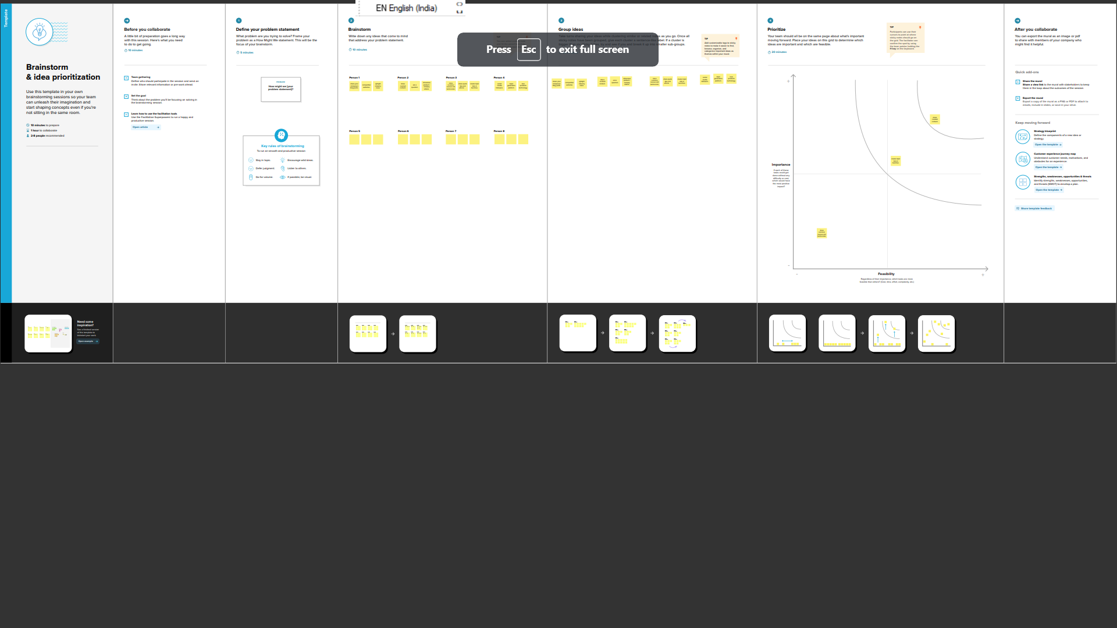

1. RESULT

Final flindings (output)of the project along with screenshot

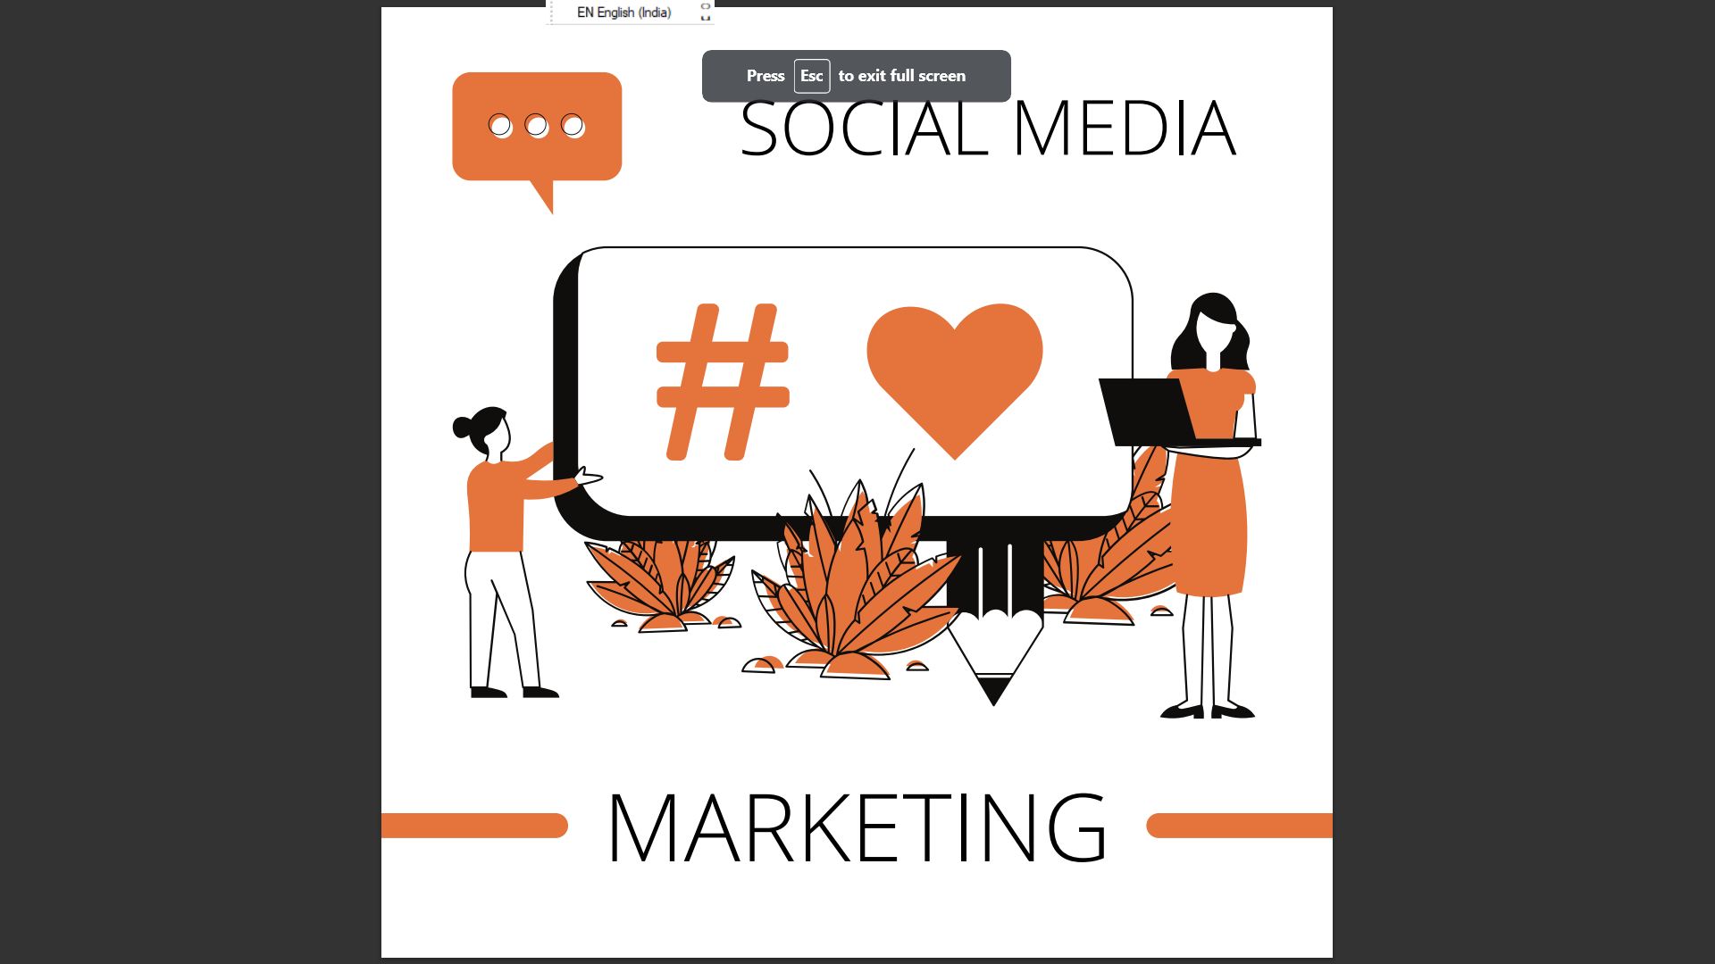

1. ADVANTAGES & DISADVANTAGES

1.Social media usage also helps you build you brand because

It enables sharing.

2.which helps expose your brand to more people.

3.stay update with all the new things in the world.

4.Easy to build relationship and connecting with like

-minded people.

5 APPLICATIONS

One of the first content creation apps we’re going to look

Into is canva,video scribe ,coming in at number two is

Video scribe.

1. CONCLUSION

The excessive use of social media and the internet has

Negative impacts on the lives of people.